Case Study & Software Requirements Specification

for

Tiffin Delivery and Management System

Version 1.0 approved

**Prepared By Project Team 02 :**

|  |  |
| --- | --- |
| **Name** | **PRN** |
| Shubhanshu Jaiswal (PL) | 230340320107 |
| Shweta Akash Bhosale | 230340320109 |
| Khagesh Sunil Nemade | 230340320047 |
| Amit Rajendra Danole | 230340520013 |
| Jyoti Vaibhav Jadhav | 230340320044 |

**Centre for Development of Advanced Computing**

Raintree Marg, Near Bharati Vidyapeeth, Opp. Kharghar Railway Station, Sector 7,

CBD Belapur, Navi Mumbai - 400 614 - Maharashtra (India)

Phone: +91-22-27565303

Fax: +91-22-2756-0004

**Table of Contents**

|  |  |  |
| --- | --- | --- |
| **Sr. No.** | **Content** | **Page No.** |
| **1** | **INTRODUCTION TO PROJECT** |  |
|  | 1.1 Purpose | 5 |
|  | 1.2 Scope | 5 |
|  | 1.3 Document Conventions | 5 |
| **2** | **REQUIREMENT** |  |
|  | 2.1 Functional Requirements | 6 |
|  | 2.1 Non-Functional Requirements | 9 |
| **3** | **DESIGN** |  |
|  | 3.1 Database Design | 11 |
| **4** | **CODING STANDARD IMPLEMENTED** |  |
|  | 4.1 Naming and Capitalization | 14 |
|  | 4.2 Comments | 15 |
| **5** | **OTHER NON_FUNCTIONAL REQUIREMENTS** |  |
|  | 5.1 Performance Requirements | 16 |
|  | 5.2 Safety Requirements | 16 |
|  | 5.3 Security Requirements | 16 |
|  | 5.4 Software Quality Attributes | 17 |
| **6** | **REFERENCES** | **18** |

**Appendices**

|  |  |  |
| --- | --- | --- |
| **Sr. No.** | **Content** | **Page No.** |
| **1** | **Appendix 1- Project Diagrams** |  |
|  | * 1. Entity Relationship Diagram | 19 |
|  | 1.2 Data Flow Diagram | 20 |
|  | 1.3 Class Diagram | 23 |
| **2** | **Appendix 2- Project WebBrowser Images** |  |
|  | 2.1 Home Page | 24 |
|  | 2.2 Login Page | 24 |
|  | 2.3 Registration Page | 25 |
|  | 2.4 User Tiffin Order | 25 |
|  | 2.5 User Profile Edit | 26 |
|  | 2.6 Order Details | 26 |
|  | 2.7 Payment Gateway | 27 |
|  | 2.8 Admin Dashboard | 27 |
|  | 2.9 Management of Tiffin | 28 |
|  | 2.10 Add New Tiffin | 28 |
|  | 2.11 Add New Delivery Area | 29 |
|  | 2.12 Delivery Address List | 29 |
|  | 2.13 User List | 30 |
|  | 2.14 Active Customer List: | 30 |
|  | 2.15 Assign Delivery Boy: | 31 |
|  | 2.16 Dispatched Orders | 31 |
|  | 2.17 Delivering Tiffin Orders (Delivery Boy): | 32 |
|  | 2.18 Delivered Order | 32 |

# 1.INTRODUCTION TO PROJECT

The web based “Tiffin Delivery and Management System” project is an attempt to simulate the basic concepts of Tiffin Delivery and Management chain. The system is designed mainly through the perspective of the tiffin provider.

Customer needs to Sign up and check the menu and order the tiffin as per the requirement for required period. Customer needs to add his/her address where the tiffin needs to be delivered before ordering the tiffin. As per customers requirement he/she must have to do payment for the amount generated for that period according to the chosen tiffin.

The system allows the admin to post the tiffin details, manage orders and delivery staff. The admin can add new tiffin in the system, edit the existing system & delete the tiffin as per the requirement of mess provide. Admin can add new addresses where mess are available to deliver the tiffin. Admin can manage the customers. He can get currently active customers who are ordering tiffin’s from this system & can able to delete the inactive customers. Admin can add new Delivery Boy to the system & able to delete the existing Delivery Boy.

When user orders the tiffin, then that tiffin is moved to the “Pending Orders” category. When the tiffin is ready in the local mess, the admin must assign delivery boy to that particular order. After assigning the delivery boy, the status of that order is changed from “Pending” to “Dispatched.” The Delivery Boy has a basic role to accept the order and deliver the tiffin to mentioned address/location. After delivering tiffin to the specified address, the order is moved from “Dispatched” to “Delivered.”

**1.1 Purpose**

The purpose of the "Tiffin Delivery and Management System" is to streamline the tiffin ordering and delivery process, providing a seamless experience for customers, efficient menu management for admins, and effective order tracking for delivery staff.

**1.2 Scope**

The system encompasses user registration, menu management, tiffin ordering, order status tracking, and administrative functions. It enables secure transactions, menu updates, and real-time delivery tracking, enhancing the overall customer experience.

**1.3** **Document Conventions**

*This document uses the following conventions.*

|  |  |
| --- | --- |
| DB | Database |
| MySql | My Structured Query Language. |
| AWS | Amazon Web Services |
| JWT | JSON Web Token |

**2.REQUIREMENTS**

**2.1 FUNCTIONAL REQUIREMENTS**

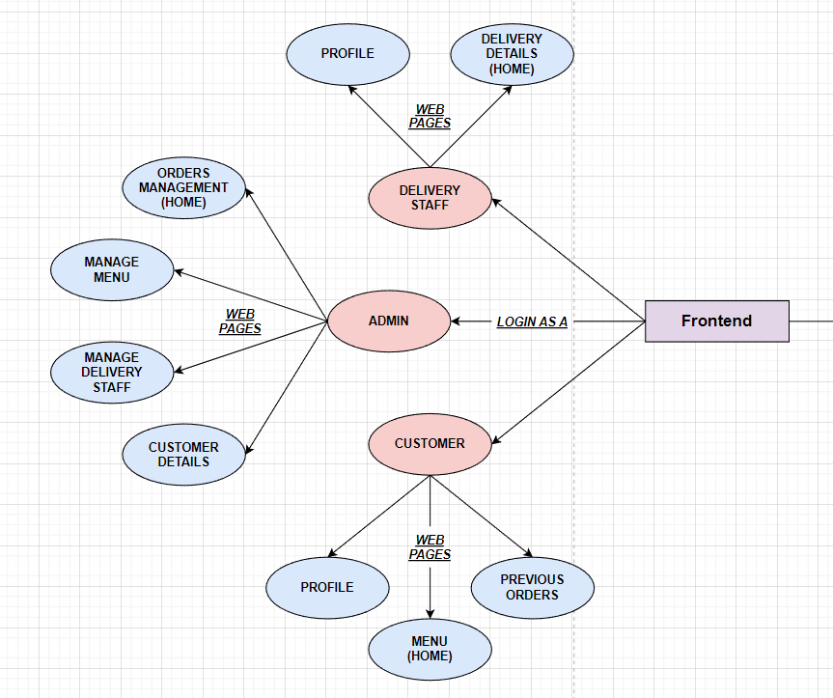

**2.1.1 User Account**

The frontend design of this website is done on widely used React-JS Technology which is very powerful and lightweight as it supports single page application it is faster to render and use advance way of session tracking using JWT token. Basically we have three roles User, Admin and Delivery boy so with reference to above diagram admin will have total control on his business. Initially through sign in page admin will authenticate and authorize himself this is done by widely used technology called JWT(Jason Web Token) after this he will get to know his total functionality through which he will manage the menu of tiffin if and new requirement hits him he can work accordingly and add new type of tiffin in their business. Also, If the business group decide for expansion they can increase their area as they have an option of manipulating their delivery area. Admin will also have a functionality to add delivery boy or delete any delivery boy who left the work and no longer needed. The order management functionality will give him total control over the ongoing order prepared ordered and delivered order thank to RDBMS for maintaining these information in well managed structured format. For User at abstract level he will use to know the tiffin detail information and according he can checkout and choose his duration one user can order more than one tiffin at a time the payment gateway will make sure the user will pay more securely as payment give to him. Delivery boy will have the functionality that to update the delivery status when the tiffin reaches its destination.

**2.1.2 Registration and creation of user profile:**

**Admin:**

The Admin role is key role of this business and the admin of the app is basically out customer for our web app development team. So basically, Admin is the owner of that mess or canteen. So, there are limited admin for any kind of business and the variation seen in them is very rare so at the time of deployment of this web app we will provide Admin with his username and Passwords as given by him, so basically, we are not going to register the admin via registration page we will add admin during the development phase of this app.

**Customer:**

Customer is basically vary as per the time so at the registration page customer have to fill his necessary details such as email id, contact number, Aadhar No, User name and Password. When the user fills this information backend of this Web App is using spring boot and core technology so it provides the encryption and decryption of password so it will make sure the data safety from Database Admin also. When the registration process completed user redirected to login page through which he could login to main page where he can see the menus and choose accordingly also he can change his profile for updating credentials and can also delete his account.

**Delivery Guy:**

The delivery boy will have same registration as customer but by choosing role accordingly he will get register as the delivery boy.

**2.1.3 Tiffin Addition**

This functionality is the core of admin role. As admin will opens the add menu. He will be forwarded to the page which will have tiffin name tiffin image tiffin description and the price of that tiffin the tiffin image can be uploaded via his local machine. After setting the price on clicking the add tiffin button the tiffin is added to database and ready for customer to order.

**2.1.4 Pathway of Tiffin Order**

Whenever the customer will sign in he will get to know the menu list when he choose particular menu he will have to fill the number of days for which he will required after doing this he has to click on order now he will automatically redirected to the payment gateway where he will choose the payment option as payment is done he will again redirected to the main page . now this tiffin is added in order list column with the unprepared status. Whenever the order will prepared admin will update the status and assign the delivery boy now delivery boy will have address on which he have to deliver the order when the package reaches the customer the delivery boys will update the status to delivered by doing this Admin will get to know that order is delivered perfectly.

**2.2 NON-FUNCTIONAL REQUIREMENTS**

**2.2.1 Operating Environment**

The operating environment for the project consists of the following hardware and software components:

**Hardware:**

• A machine with at least 8GB of RAM and a fast processor, such as Intel Core i5 or

higher, to ensure smooth and efficient execution of the project**.**

**Software:**

**•** ReactJS for the frontend development.

• Spring Boot for the backend development

• MySQL for the database management.

• JWT Authentication for security.

• AWS for deployment.

**Other Applications:**

• Code editor (such as Visual Studio Code, Eclipse)

• Git version control software

• Command line interface (CLI) or terminal

• A browser for testing the application.

• Postman for testing APIs.

• MySQL Workbench or another database management tool

• An AWS account for deployment.

**2.2.2 Design and Implementation Constraints**

• User interface is only in English. No other language option is available.

• Compatibility issues while mapping Frontend to two backends.

• Parallel Operations may load the system and not function smoothly

• Limited to HTTPS.

**3. DESIGN**

**3.1 Database Design**

The following table structures depict the database design.

# Table1: User Details:

|  |  |  |  |
| --- | --- | --- | --- |
| **Column Name** | **Data Type** | **Length** | **Allow Null (1=Yes;0=No)** |
| user_id | int | 4 | 0 |
| aadhar_no | Varchar(255) | 255 | 1 |
| email | Varchar(255) | 255 | 0 |
| password | Varchar(255) | 255 | 1 |
| phone | Varchar(255) | 255 | 1 |
| role | Varchar(255) | 255 | 1 |
| user_name | Varchar(255) | 255 | 1 |

# Table2 : User Address Details:

|  |  |  |  |
| --- | --- | --- | --- |
| **Column Name** | **Data Type** | **Length** | **Allow Null (1=Yes;0=No)** |
| address_id | int | 4 | 0 |
| address_line1 | Varchar(255) | 255 | 1 |
| user_id | int | 4 | 1 |
| location_id | int | 4 | 1 |

# Table 3 :Daywise Order Details:

|  |  |  |  |
| --- | --- | --- | --- |
| **Column Name** | **Data Type** | **Length** | **Allow Null (1=Yes;0=No)** |
| do_id | int | 4 | 0 |
| date | date | 8 | 1 |
| requirement | int | 4 | 1 |
| status | Varchar(255) | 255 | 1 |
| delivery_boy_id | int | 4 | 1 |
| order_id | int | 4 | 1 |

## Table 4: Orders Details:

|  |  |  |  |
| --- | --- | --- | --- |
| **Column Name** | **Data Type** | **Length** | **Allow Null (1=Yes;0=No)** |
| OrderID | int | 4 | 0 |
| UserID | int | 6 | 0 |
| StartDate | date | 6 | 1 |
| EndDate | date | 6 | 1 |
| TotalDays | int | 3 | 1 |
| TotalAmount | int | 3 | 1 |
| TiffinID | int | 4 | 0 |

# Table 5: Payment Details:

|  |  |  |  |
| --- | --- | --- | --- |
| **Column Name** | **Data Type** | **Length** | **Allow Null (1=Yes;0=No)** |
| transaction_id | Int | 4 | 0 |
| payment_type | Varchar(50) | 50 | 0 |
| Total_payment | Date | 6 | 1 |
| Payment_status | Date | 6 | 1 |
| Payment_time | TimeStamp | 3 | 1 |

# Table 6 : Delivery_Address:

|  |  |  |  |
| --- | --- | --- | --- |
| **Column Name** | **Data Type** | **Length** | **Allow Null (1=Yes;0=No)** |
| location_id | int | 4 | 0 |
| delivery_area | Varchar(255) | 255 | 1 |
| city | Varchar(255) | 255 | 1 |
| pincode | int | 6 | 1 |

**Table 7 :Tiffin_Details:**

|  |  |  |  |
| --- | --- | --- | --- |
| **Column Name** | **Data Type** | **Length** | **Allow Null (1=Yes;0=No)** |
| tiffin_id | int | 4 | 0 |
| tiffin_name | Varchar(255) | 255 | 1 |
| tiffin_image | Blob | 255 | 1 |
| tiffin_price | Int | 6 | 1 |
| description | Varchar(500) | 500 | 1 |

**4. CODING STANDARDS IMPLEMENTED**

### 4.1 Naming and Capitalization

Below summarizes the naming recommendations for identifiers in Pascal casing is used mainly (i.e., capitalize first letter of each word) with camel casing (capitalize each word except for the first one) being used in certain circumstances.

|  |  |  |  |
| --- | --- | --- | --- |
| **Identifier** | **Case** | **Examples** | **Additional Notes** |
| Class | Pascal | Person, BankVault, SMSMessage, Dept | Class names should be based on "objects" or "real things" and should generally be **nouns**. No ‘_’ signs allowed. Do not use type prefixes like ‘C’ for class. |
| Method | Camel | getDetails, updateStore | Methods should use **verbs** or verb phrases. |
| Parameter | Camel | personName, bankCode | Use descriptive parameter names. Parameter names should be descriptive enough that the name of the parameter and its type can be used to determine its meaning in most scenarios. |
| Interface | Pascal with "I" prefix | Disposable | Do not use the ‘_’ sign |
| Property | Pascal | ForeColor, BackColor | Use a noun or noun phrase to name properties. |
| Associated private member variable | _camelCase | _foreColor, _backColor | Use underscore camel casing for the private member variables |
| Exception Class | Pascal with "Exception" suffix | WebException, |  |

### 4.2 Comments

* Comment each type, each non-public type member, and each region declaration.
* Use end-line comments only on variable declaration lines. End-line comments are comments that follow code on a single line.
* Separate comments from comment delimiters (apostrophe) or // with one space.
* Begin the comment text with an uppercase letter.
* End the comment with a period.
* Explain the code; do not repeat it.

**5. OTHER NONFUNCTIONAL REQUIREMENTS**

**5.1 Performance Requirements**

The performance requirements of the project should outline the expected speed, reliability, scalability, and efficiency of the system. This may include the maximum response time for user actions, the expected uptime percentage, the ability to handle increasing numbers of users and submissions, and the resource usage of the system. These requirements should be realistic and achievable, taking into account factors such as hardware limitations and network bandwidth.

They should also be measurable and verifiable, allowing the system to be tested and evaluated against the defined standards.

**5.2 Safety Requirements**

The system should be reliable and have minimal downtime to ensure that students can submit assignments and receive feedback in a timely manner. The user interface should be intuitive and user-friendly to prevent errors or misunderstandings while using the app. The app should have robust error handling mechanisms to deal with unexpected situations and prevent any harm to the user or loss of data.

**5.3 Security Requirements**

The project would include measures to protect the confidentiality, integrity, and availability of sensitive information such as students' assignments, grades, and personal information. Some of the security requirements are:

• Authentication: A secure authentication system that ensures only authorized users can access the system.

• Authorization: An authorization mechanism to determine what actions a user can perform within the system based on their role and permissions.

• Encryption: Data in transit and at rest should be encrypted to protect sensitive

information from being intercepted or accessed by unauthorized parties.

• Access Control: A mechanism to control access to sensitive information within the

system, including the ability to set permissions for different users and roles.

**5.4 Software Quality Attributes**

The software quality attributes for the project include the following:

• Usability: The user interface should be intuitive, easy to navigate and user-friendly, allowing users to easily submit and review assignments.

• Reliability: The system should be reliable and provide accurate results, ensuring that assignments are submitted and reviewed accurately and efficiently.

• Performance: The system should perform efficiently and respond quickly to user requests, allowing for fast and seamless assignment submissions and reviews.

• Scalability: The system should be scalable, allowing for an increasing number of users and assignments as the demand grows.

• Maintainability: The system should be maintainable, with easy-to-update code and well-documented processes, ensuring that updates and improvements can be made quickly and efficiently.

• Security: The system should have strong security features, protecting sensitive information and ensuring the privacy and confidentiality of user data.

• Compliance: The system should comply with relevant regulations and standards, ensuring that it operates within the bounds of the law and industry best practices.

**6. REFERENCES:**

<http://www.google.com>

https://anvitiffin.rekart.io/home

<https://tiffindaily.com/>

http://www.w3.org

http://www.wikipedia.org

<http://minkfoodiee.com/foodiee/tiffin-services>

<https://meshink.xyz/tiffin-management-system.php>

Appendix 1

**Project Diagrams**

* 1. 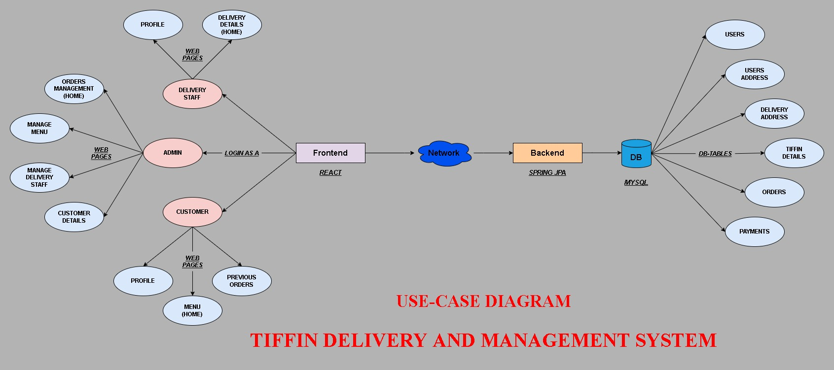Entity Relationship Diagram

**1.2 Data Flow Diagram:**

**1.2.1 Home Page :**

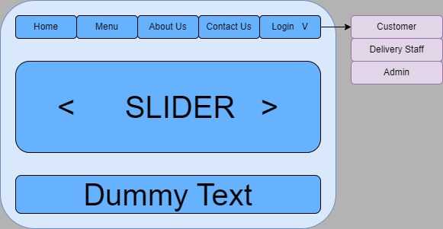

**1.2.2 Customer Dashboard:**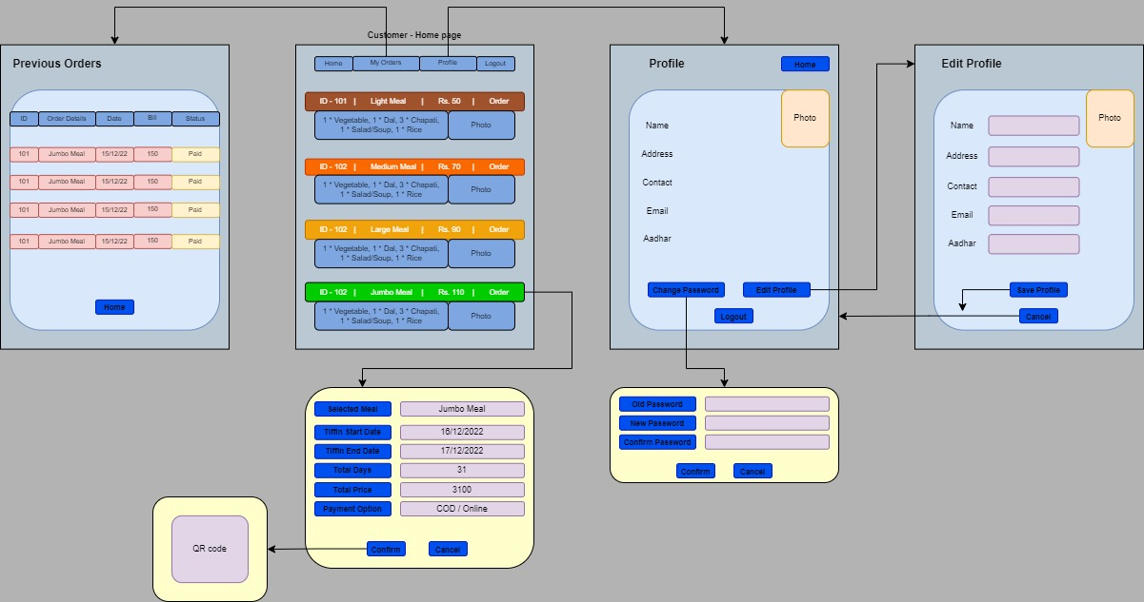

**1.2.3 Admin Dashboard:**

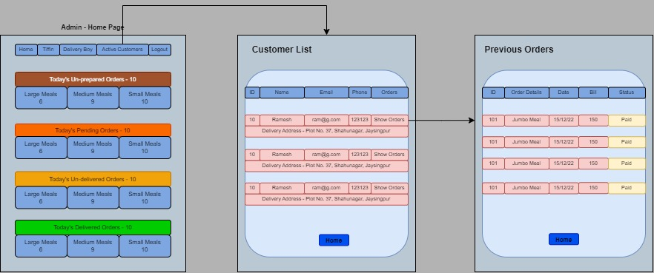**1.2.3.1 Manage Customers:**

* + - 1. **Manage Delivery Guys:**

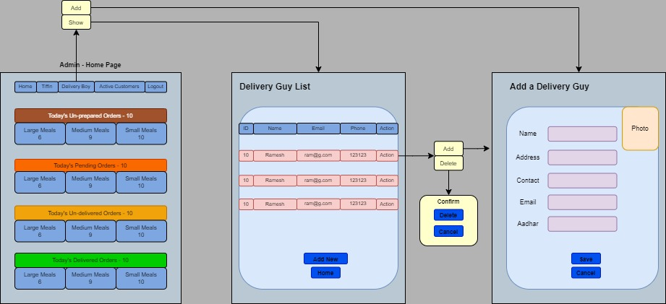

**1.2.4 Delivery Guy:**

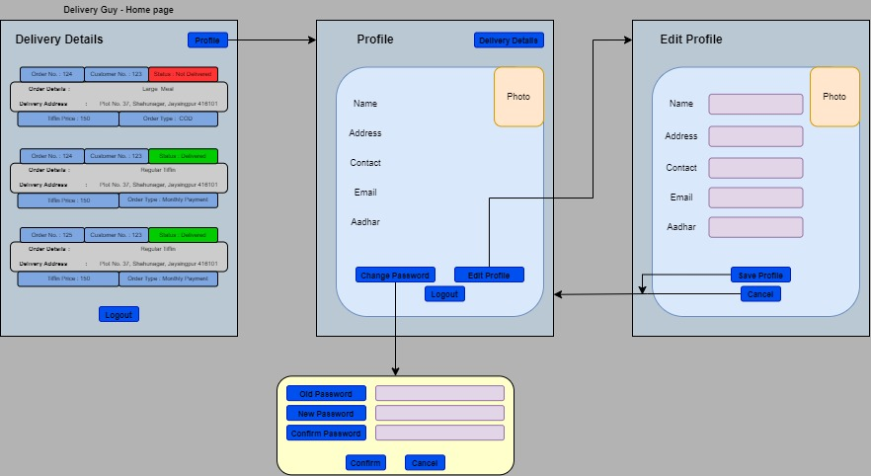

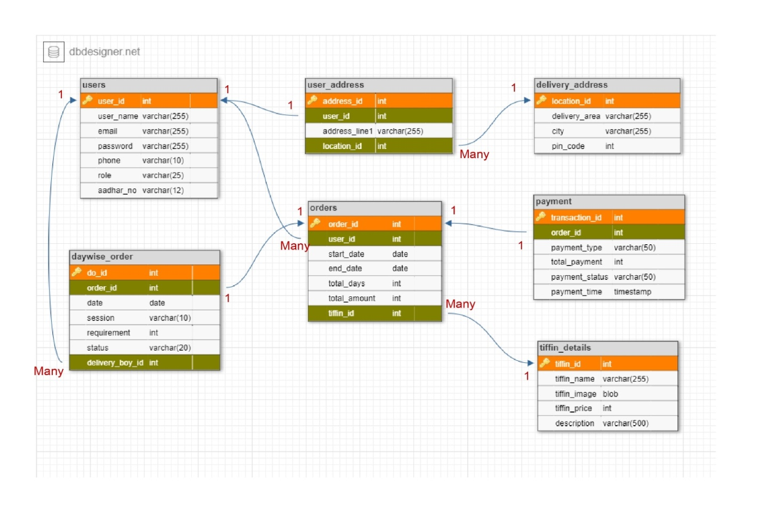 **1.3. Class Diagram**

Appendix 2

**Project WebBrowser Images**

2.1 Homepage:

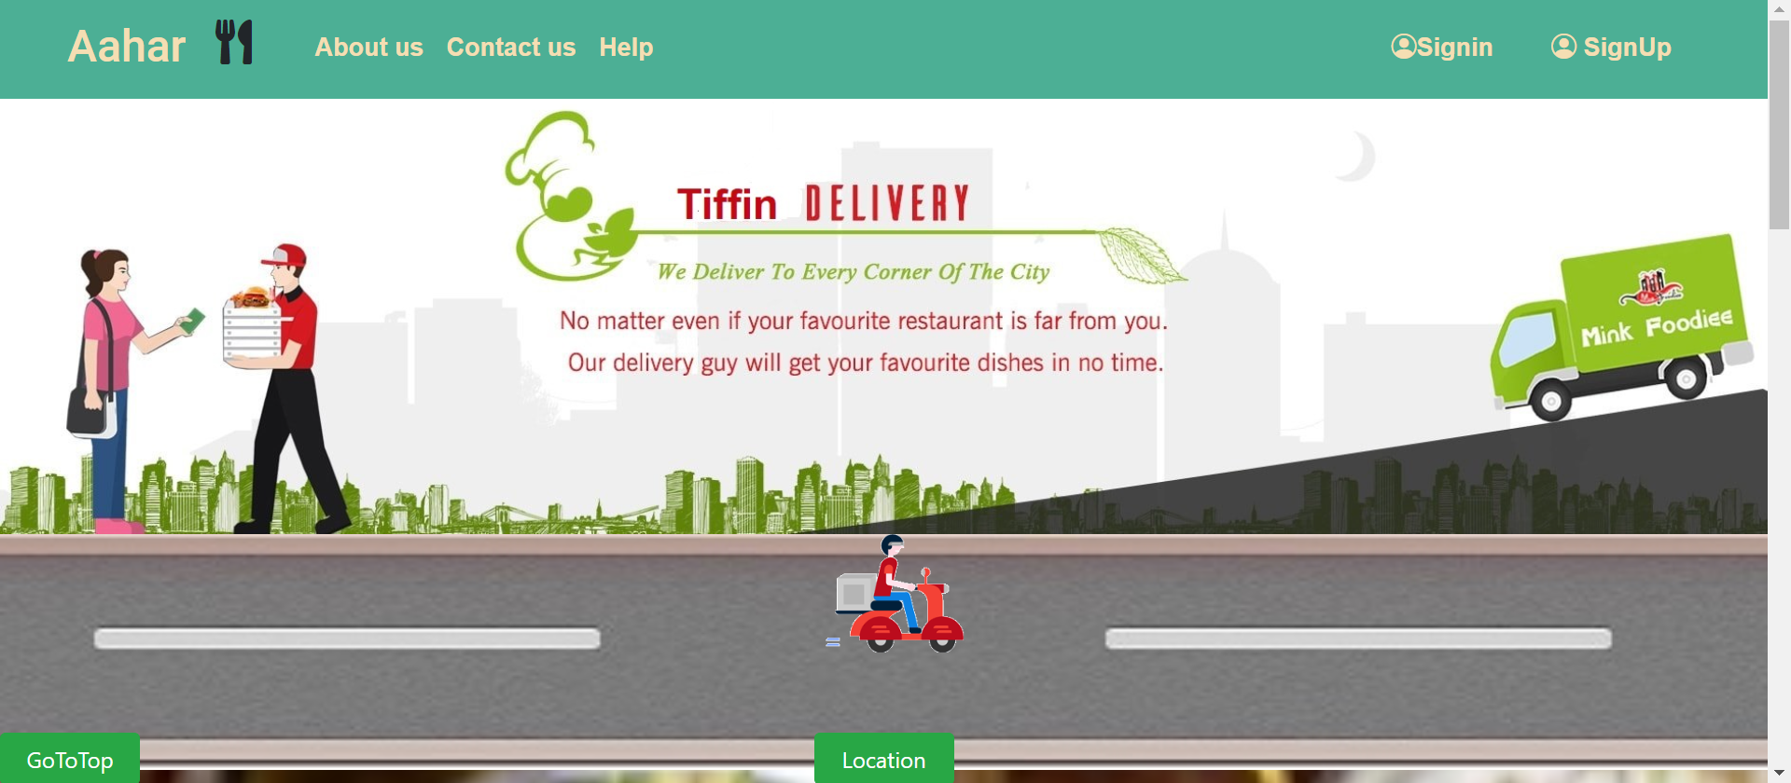

2.2 Login Page:

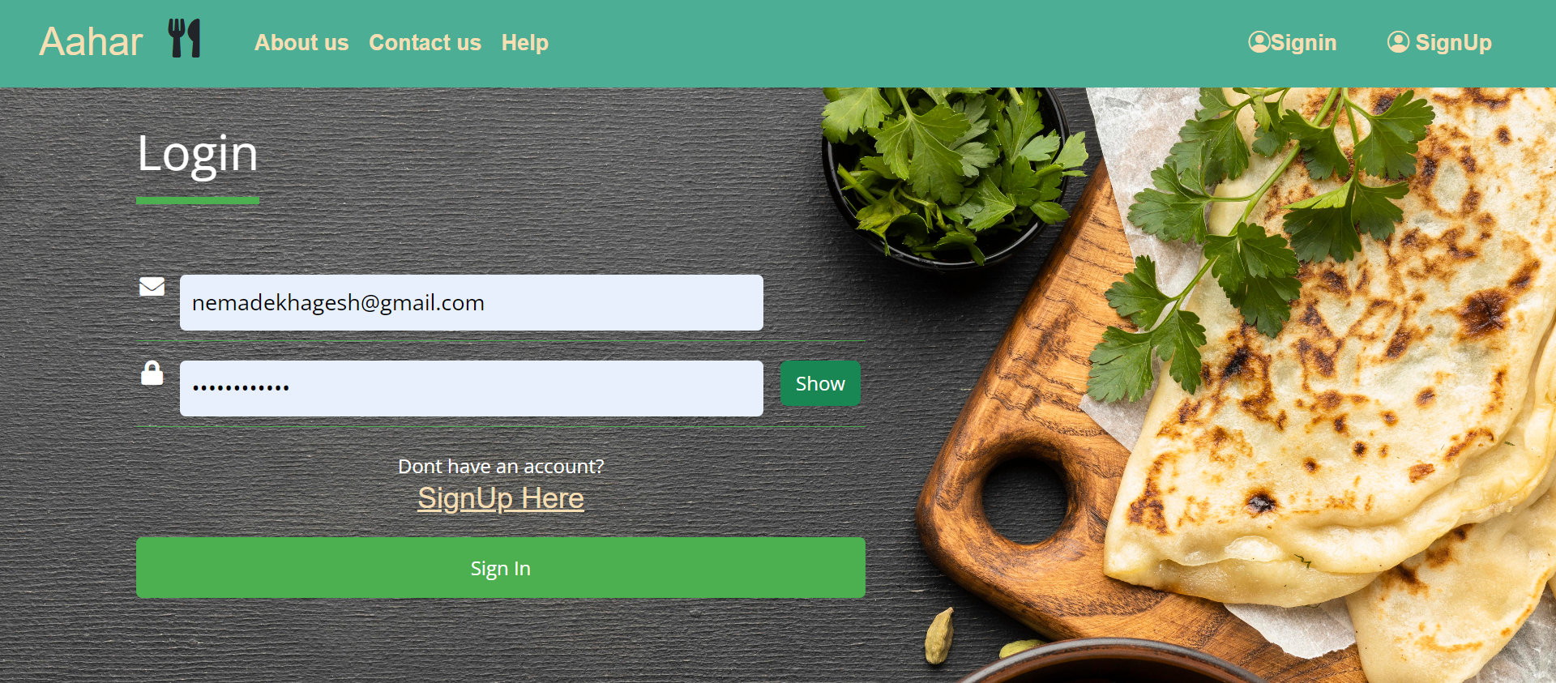

2.3 Registration Page:

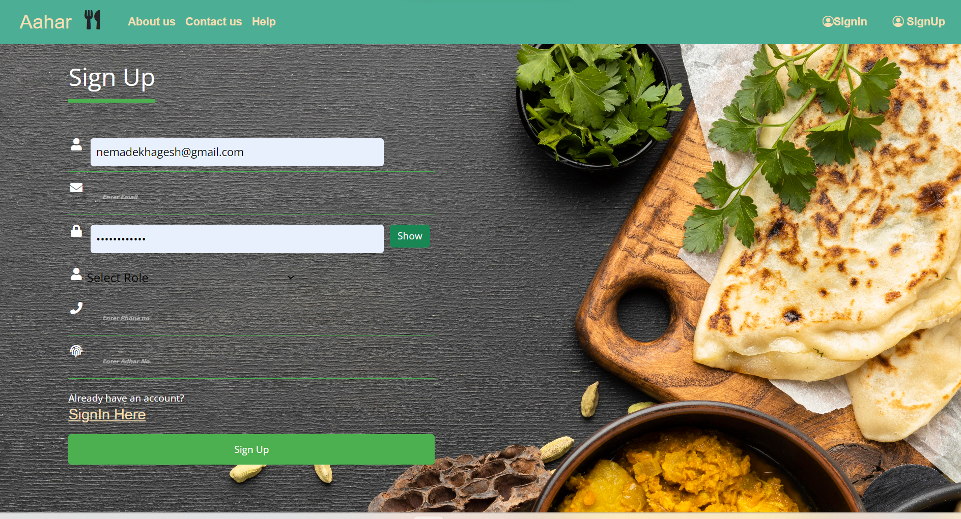

2.4 User Tiffin Order:

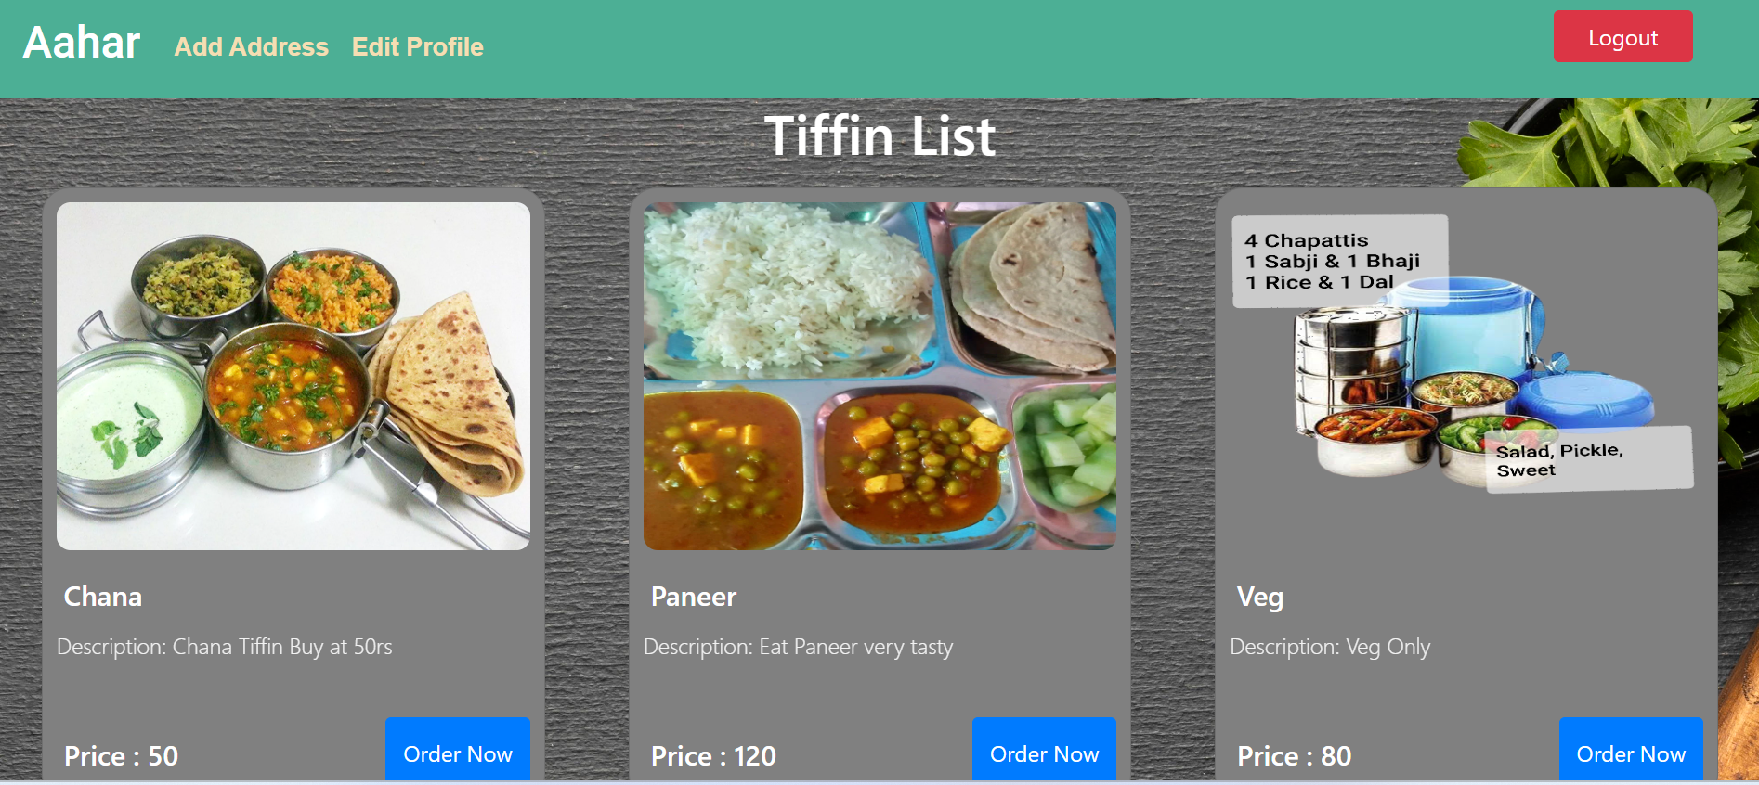

**2.5 User Profile Edit:**

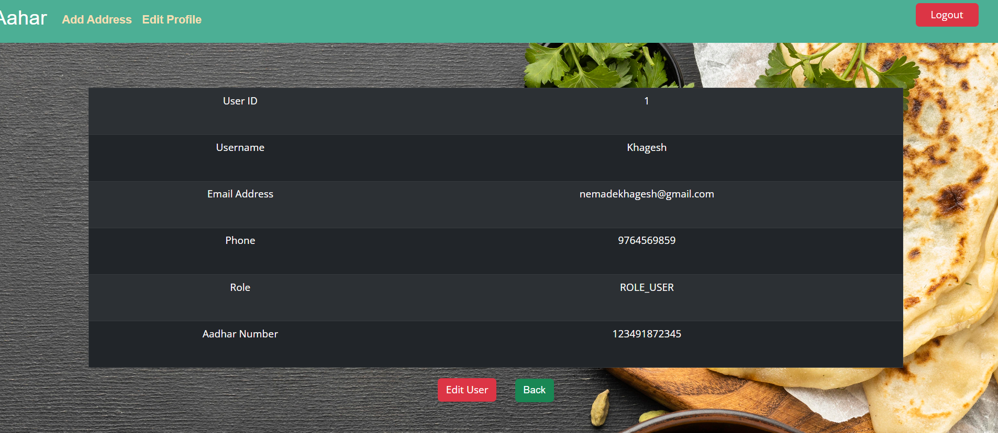

**2.6 Order Details :**

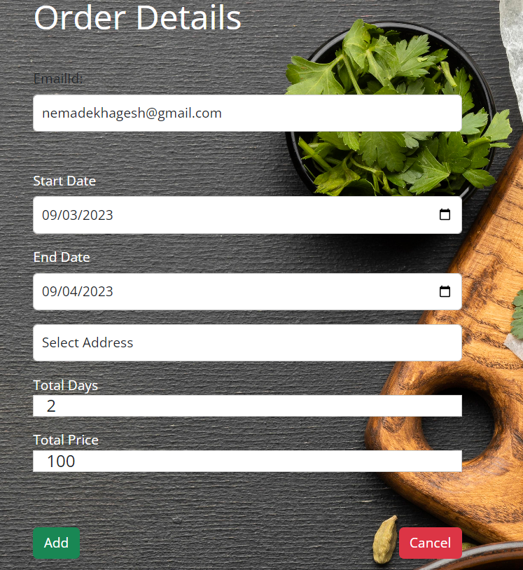

**2.7 Payment Gateway:**

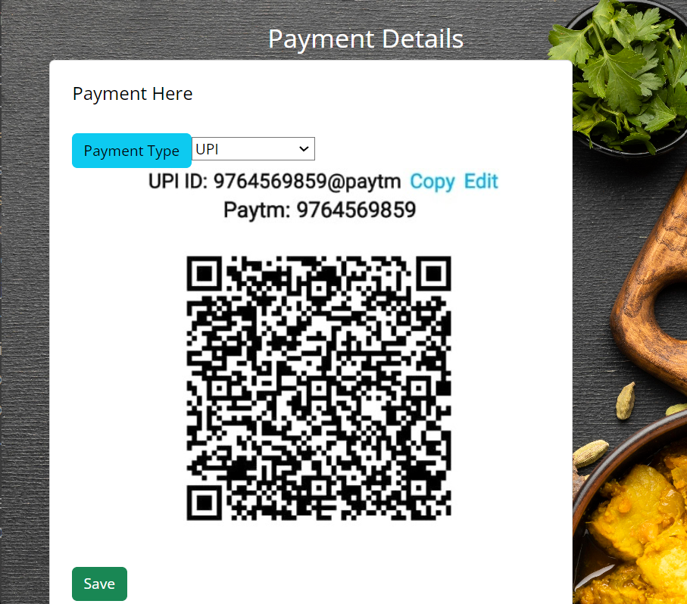

2.8 Admin Dashboard:

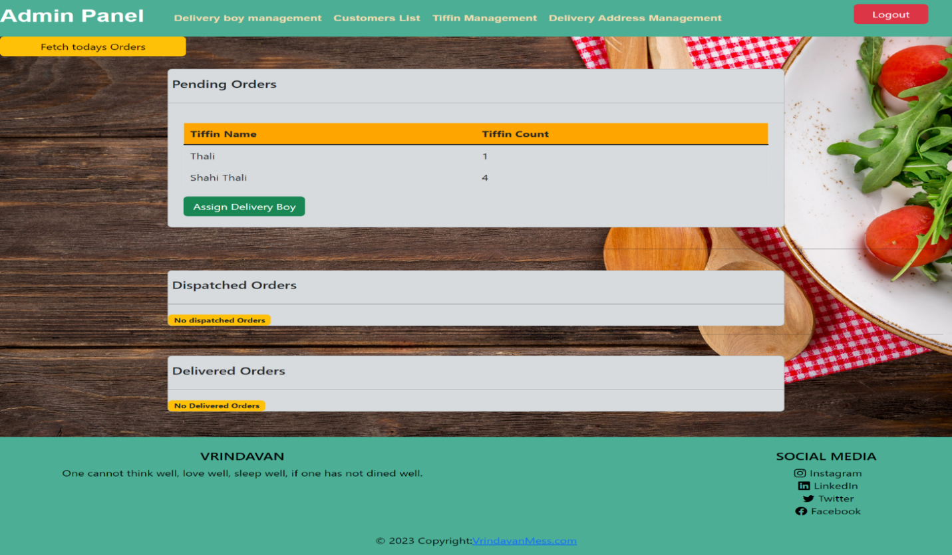

2.9 Management of Tiffin:

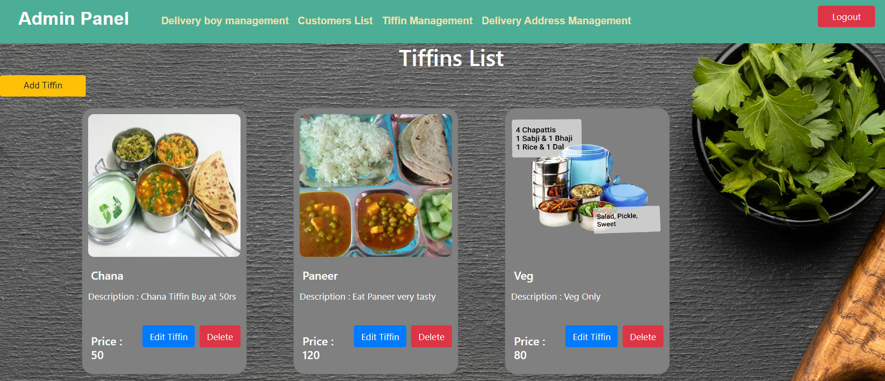

2.10 Add New Tiffin:

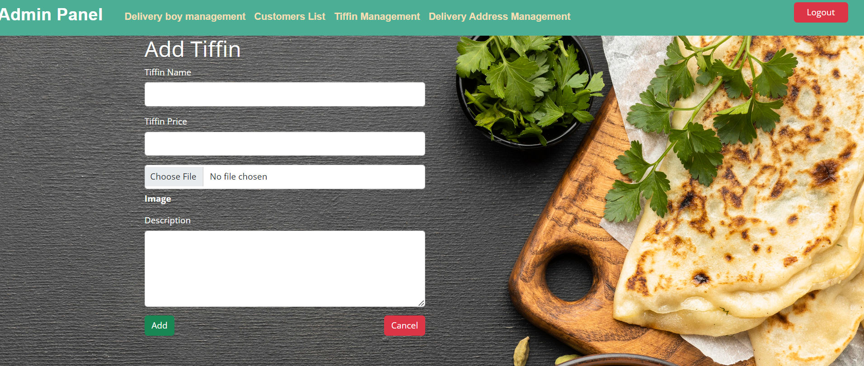

2.11 Add New Delivery Area:

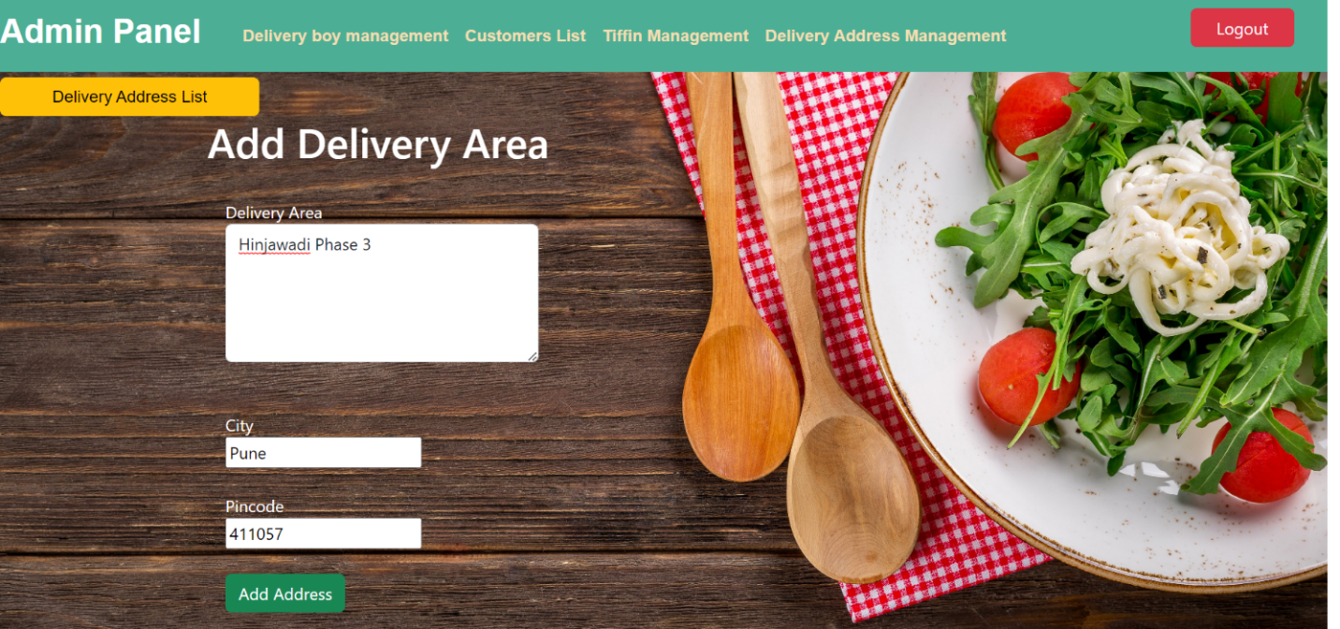

**2.12 Delivery Address List:**

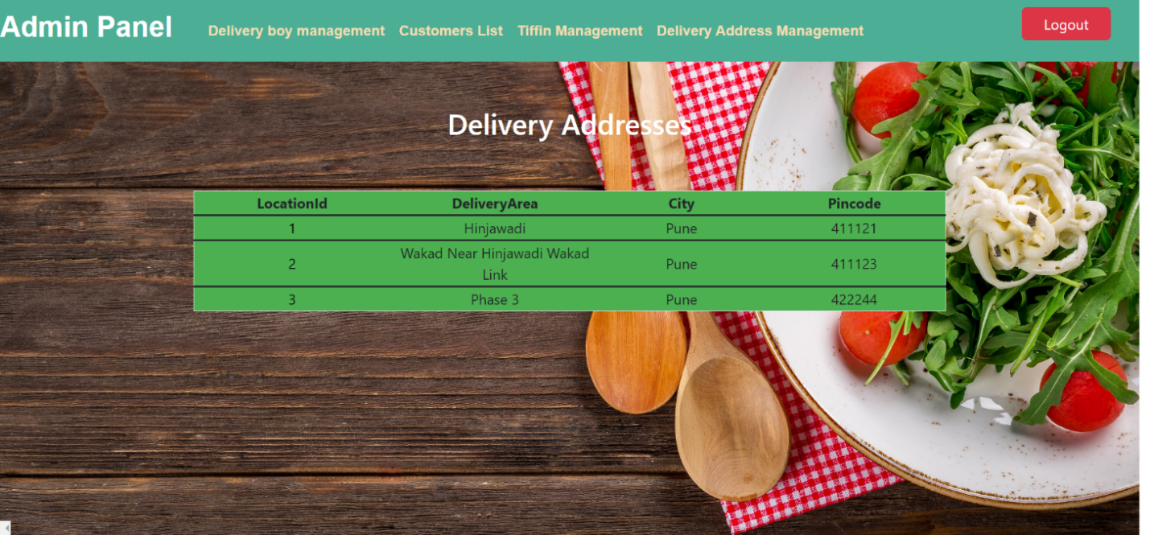

**2.13 Users List:**

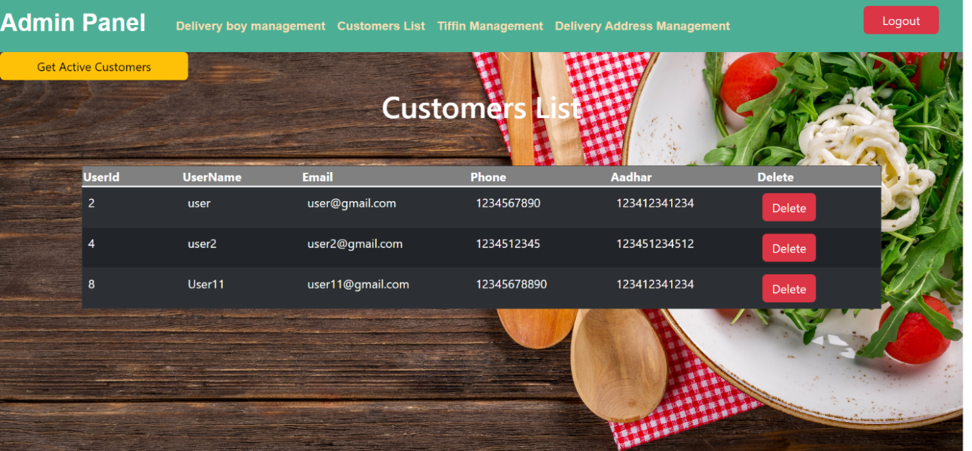

**2.14 Active Customer List:**

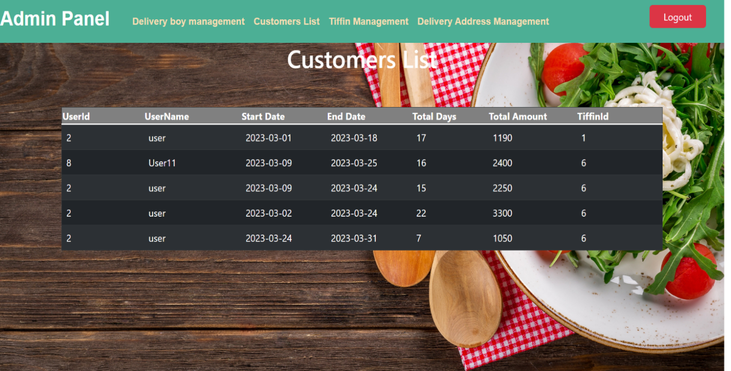

**2.15 Assign Delivery Boy:**

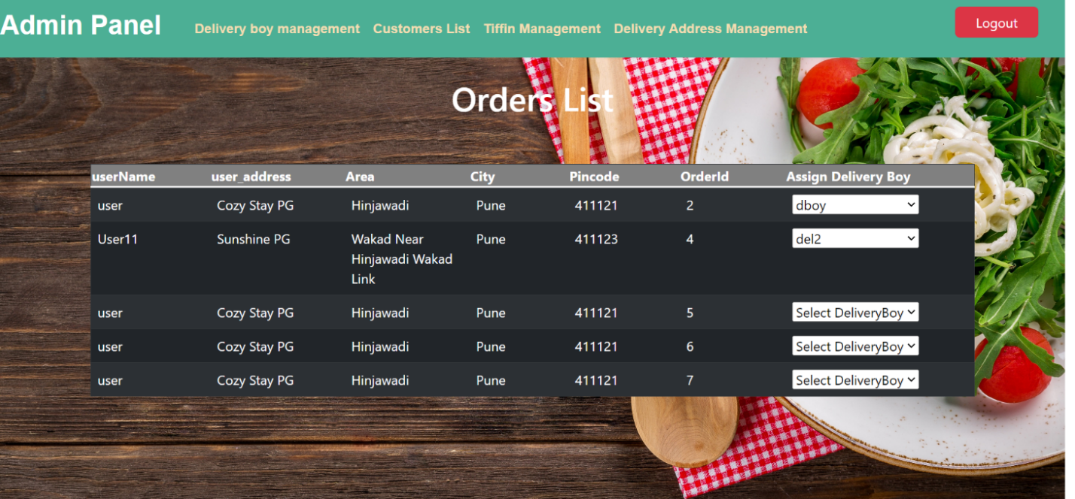

**2.16 Dispatched Orders:**

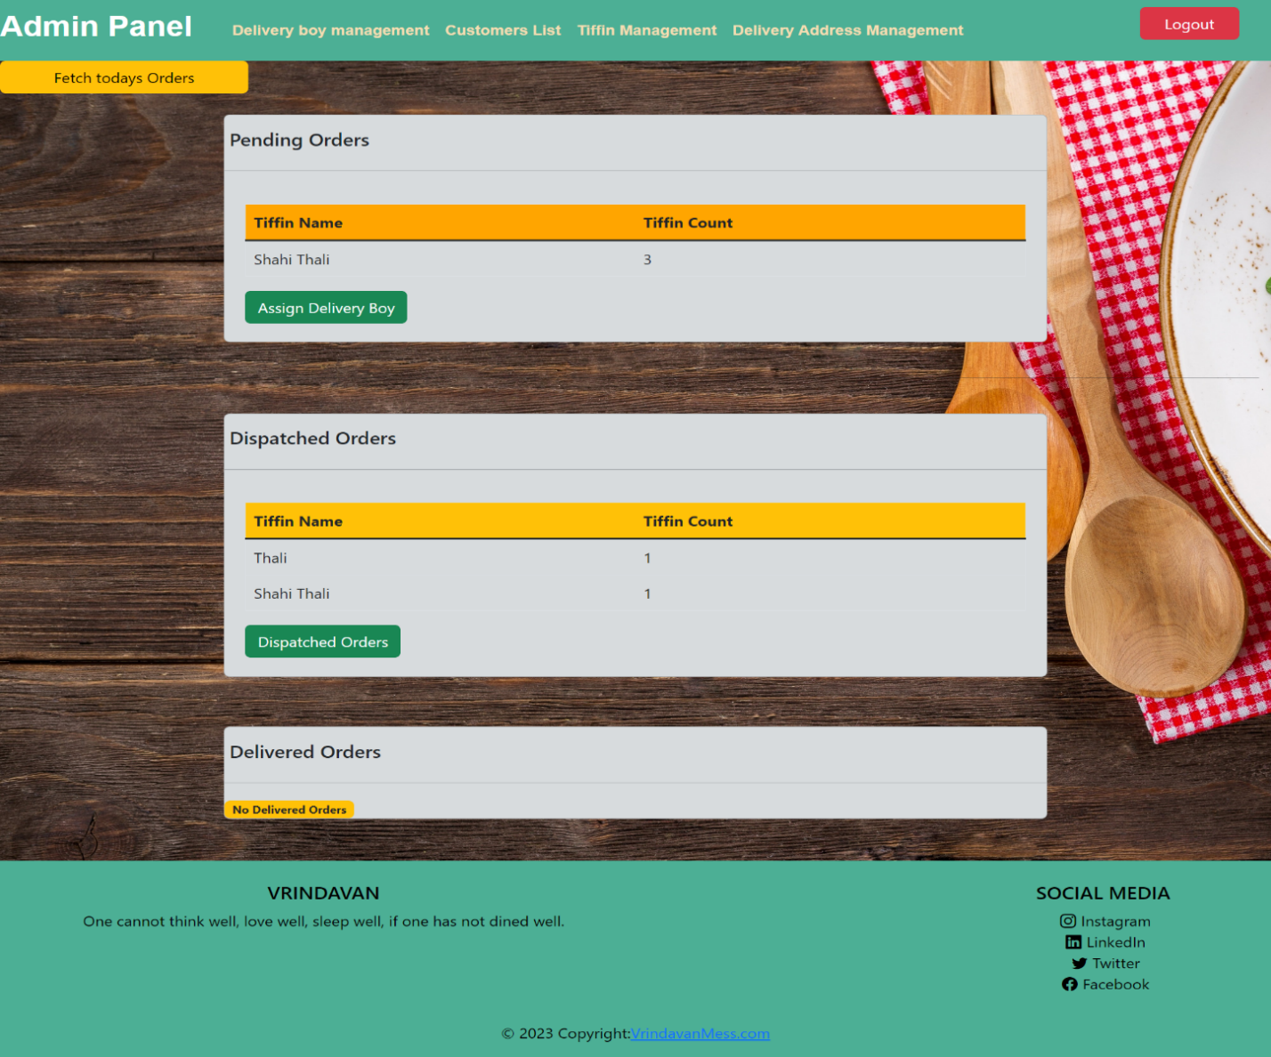

**2.17 Delivering Tiffin Orders (Delivery Boy):**

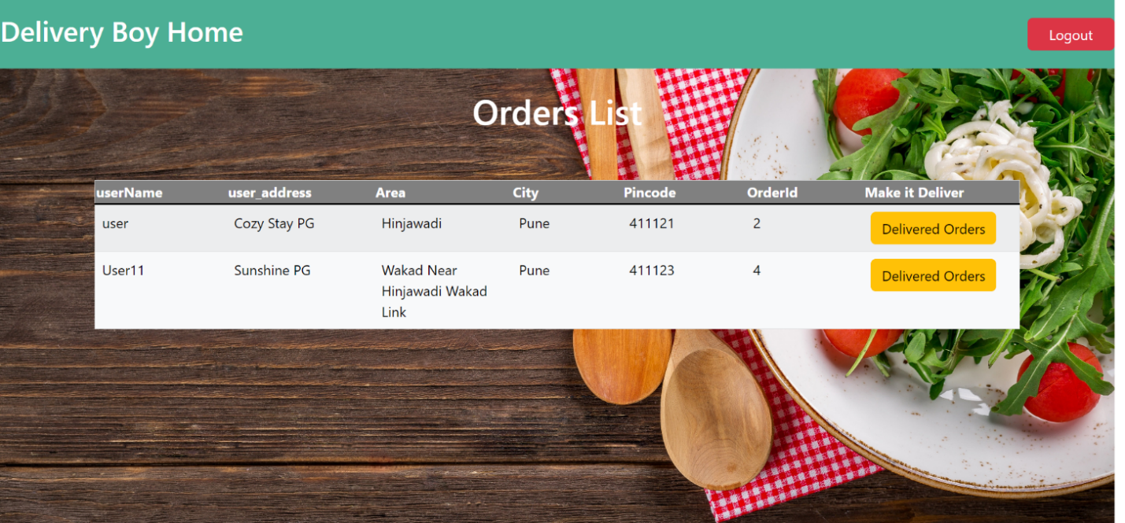

**2.18 Delivered Orders:**

